Overall Totals
- Total Actions: 722,629
- Total Loans: 229,573
- Unique Customers: 213,591

Contact Mode Breakdown
Count | Mode | %
470,490 | Physical Visit | 65.11%
252,105 | Telephone Contact | 34.89%

Recovery Chance Counts
Recovery Chance | Count
Medium | 37,095
High | 14,227
Low | 9,549

Top 10 Branches by Customer Engagement
Branch Name | Customers Contacted | Total Actions
Mehrabpur | 4,140 | 38,205
Larkana | 3,680 | 27,458
Khairpur | 3,067 | 21,214
Dadu | 3,713 | 18,631
Ranipur | 3,081 | 16,960
Kandiaro | 2,073 | 16,781
Ratodero | 2,588 | 16,210
Mehar | 1,526 | 15,559
Sammundri | 2,088 | 15,554
Thari Mirwah | 2,337 | 14,449

Top 10 Areas by Customer Engagement
Area Name | Unique Loans | Total Actions
US2 | 23,067 | 150,033
US1 | 24,429 | 98,984
SP1 | 31,937 | 71,904
KHI | 16,792 | 61,256
LSD | 12,281 | 53,546
LSD2 | 9,985 | 47,010
BLN | 14,597 | 44,251
CP2 | 11,594 | 38,524
SP5 | 11,969 | 25,409
CP4 | 9,381 | 21,124

Places Where Contact Occurred
Place Contacted | Contact Count
Home | 410,360
Others | 260,630
Office / Business | 49,393
Branch | 942

Account Severity Breakdown
Account Severity |  |  | Total Cases
Low |  |  | 300,238
Medium |  |  | 282,104
High |  |  | 84,461

Severity vs Recovery Chance
Severity | Recovery Chance |  |  |  |  | Count
High | High |  |  |  |  | 4,305
High | Low |  |  |  |  | 845
High | Medium |  |  |  |  | 1,223
Low | High |  |  |  |  | 2,145
Low | Low |  |  |  |  | 2,294
Low | Medium |  |  |  |  | 2,520
Medium | High |  |  |  |  | 2,807
Medium | Low |  |  |  |  | 1,520
Medium | Medium |  |  |  |  | 21,026

Top Branches by Total Action Amount
Branch Name |  |  |  | Total Action Amount (PKR)
Mehrabpur |  |  |  | 2,262,230,460.27
Tibba Sultanpur |  |  |  | 1,746,370,753.30
Larkana |  |  |  | 1,496,419,606.06
Ranipur |  |  |  | 1,331,982,396.44
Kehroorpacca |  |  |  | 1,066,183,810.07
Mailsi |  |  |  | 1,056,183,418.08
Dadu |  |  |  | 1,045,865,730.07
Dunyapur |  |  |  | 890,096,649.10
Shujahabad |  |  |  | 775,903,012.72
Thari Mirwah |  |  |  | 749,601,466.21

Recovery Chance by Contact Mode
Contact Mode |  |  |  | Recovery Chance | Count
Physical Visit |  |  |  | Medium | 32,286
Physical Visit |  |  |  | High | 12,314
Physical Visit |  |  |  | Low | 8,130
Telephone Contact |  |  |  | Medium | 4,809
Telephone Contact |  |  |  | High | 1,913
Telephone Contact |  |  |  | Low | 1,419

Recovery Chance Vs Broken Payment Promise
Broken Promise |  |  |  |  |  | Recovery Chance | Count
No |  |  |  |  |  | High | 5,951
No |  |  |  |  |  | Low | 2,622
No |  |  |  |  |  | Medium | 10,667
Yes |  |  |  |  |  | High | 7,761
Yes |  |  |  |  |  | Low | 6,764
Yes |  |  |  |  |  | Medium | 25,738

Financial Metrics by Recovery Chance
Recovery Chance | Total Actions |  |  |  |  | Avg Action Amount (PKR)
High | 14,227 |  |  |  |  | 55,785.57
Low | 9,549 |  |  |  |  | 47,756.19
Medium | 37,095 |  |  |  |  | 70,648.62

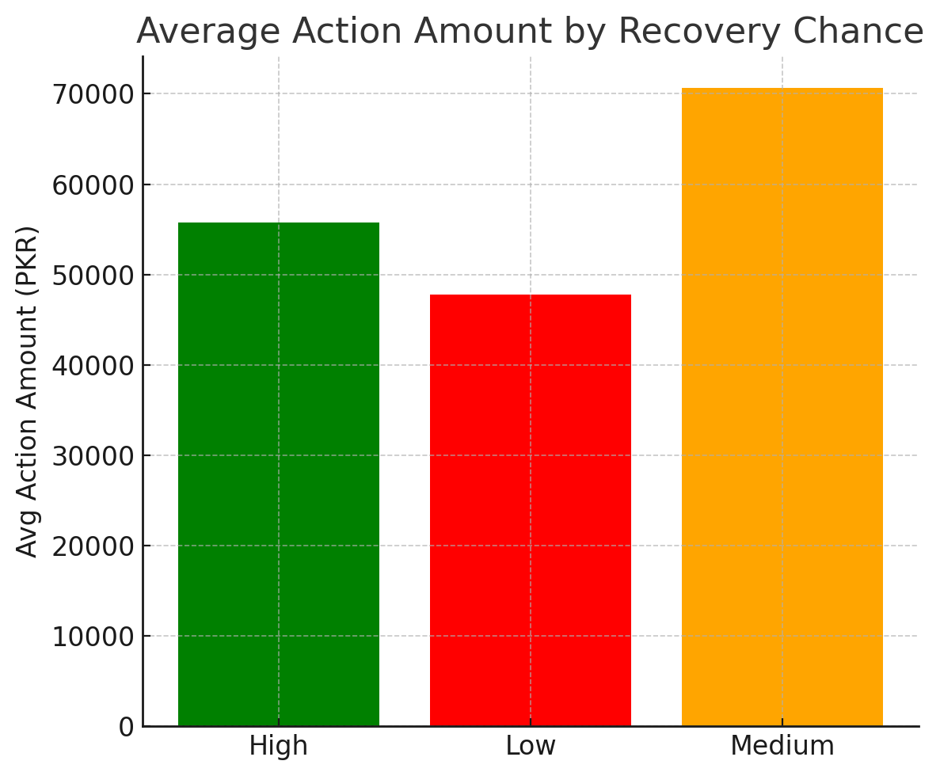
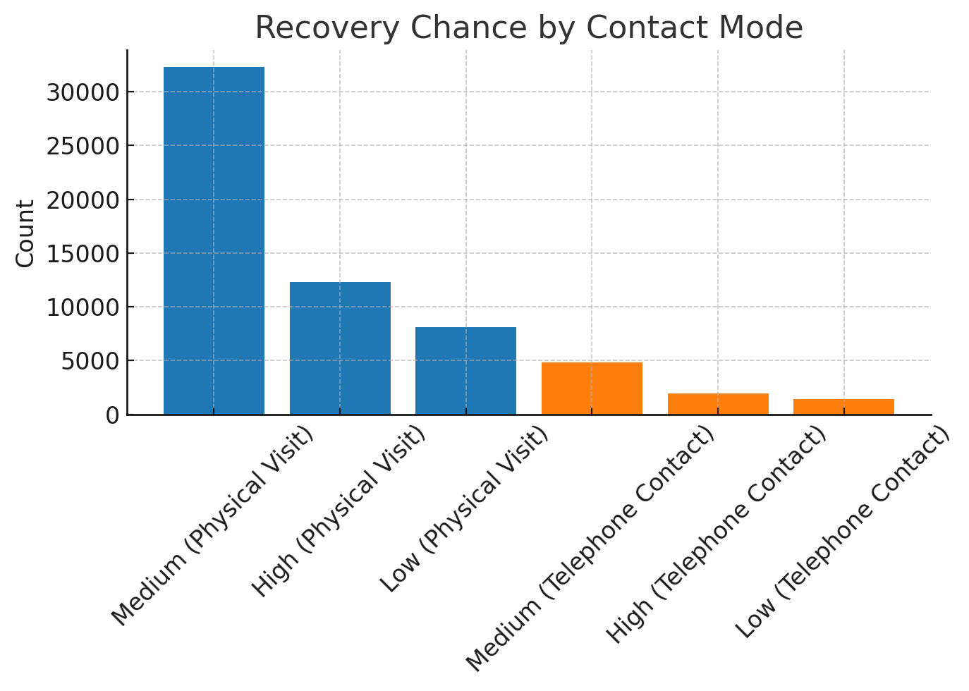
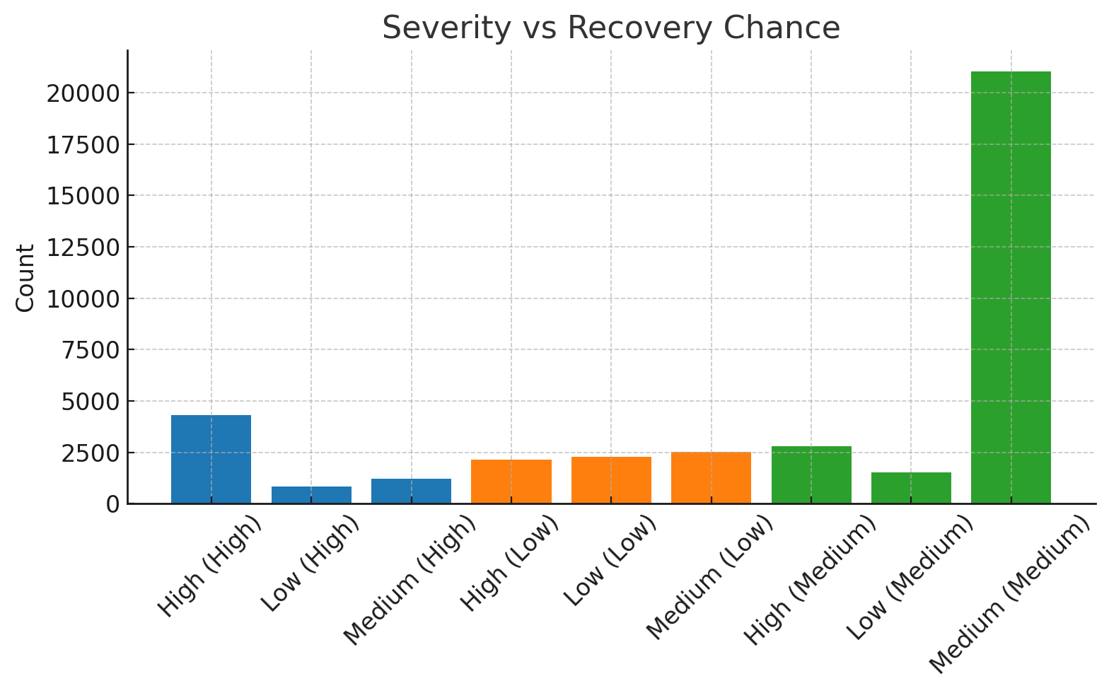

Issue | Row Count | Description
1. Contact Mode is null | 50 | Missing contact mode info
2. Recovery Chance invalid or null | 662,000 | Invalid format or missing
3. Invalid Contact Location | 1,300 | Invalid value for contact location
4. Invalid Data Account Severity | 56,000 | Data format or value is incorrect
5. Broker Indication invalid or null | 60,000 | Missing or corrupted broker indicator
6. Action Amount is empty | 40,000 | The value is 0

